COVID-19 testing and specimen collection billing guidance

For network pharmacies wishing to provide COVID-19 testing services for MetroPlus Health Plan recipients, details regarding network participation, including claims submission requirements, were sent to Caremark-participating New York pharmacies on 07/21/2020. For a pharmacy that is a chain pharmacy or a member of a PSAO (Pharmacy Services Administrative Organization), your chain headquarters or PSAO would have received the notification. Please contact them for additional information. If you are an independent pharmacy and have not received this information, contact Caremark at 866-488-4708.

Claims Submission Information – Specimen Collection Only

When submitting to CVS Caremark for COVID-19 test specimen collection, submit the appropriate quantity and the appropriate days supply. Inappropriate quantities or days supply may cause the claim to reject. Submit “MA” in the Professional Service Code Field (440-E5) of the DUR/PPS Segment along with a positive incentive fee amount in the Incentive Amount Submitted Field (438-E3) of the Pricing Segment when submitting for administering COVID-19 test.
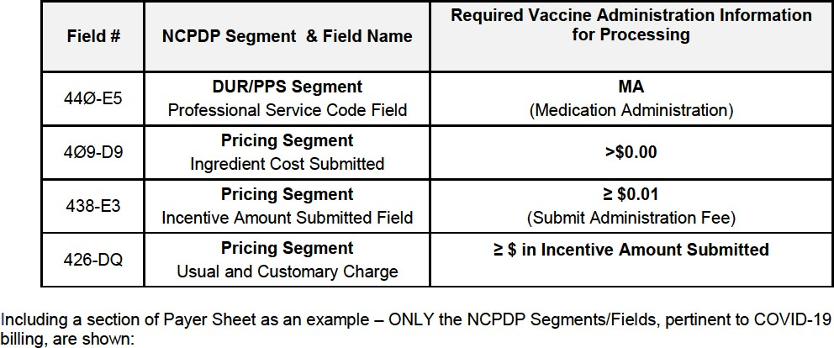

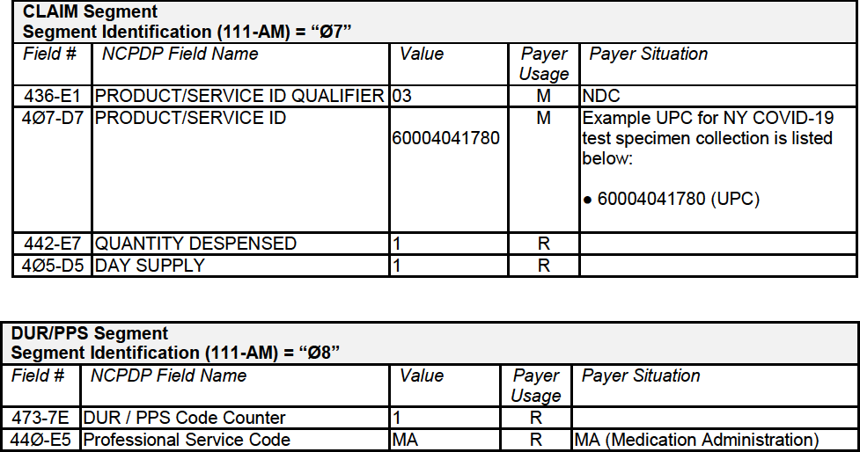

Example NDC/UPC codes only and not limited to the following:
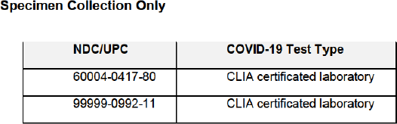

Claims Submission Information - Product with CLIA-Waived COVID Testing

When submitting for administration of a COVID-19 test to CVS Caremark, submit the appropriate quantity and the appropriate days supply. Inappropriate quantities or days supply may cause the claim to reject. Submit “PP” in the Reason for Service Code field (439-E4), “PT” in the Professional Service Code Field (440-E5), and “00” in the Result of Service Code field (441- E6) of the DUR/PPS Segment along with a positive incentive fee amount in the Incentive Amount Submitted Field (438-E3) of the Pricing Segment when submitting for administering COVID-19 test.

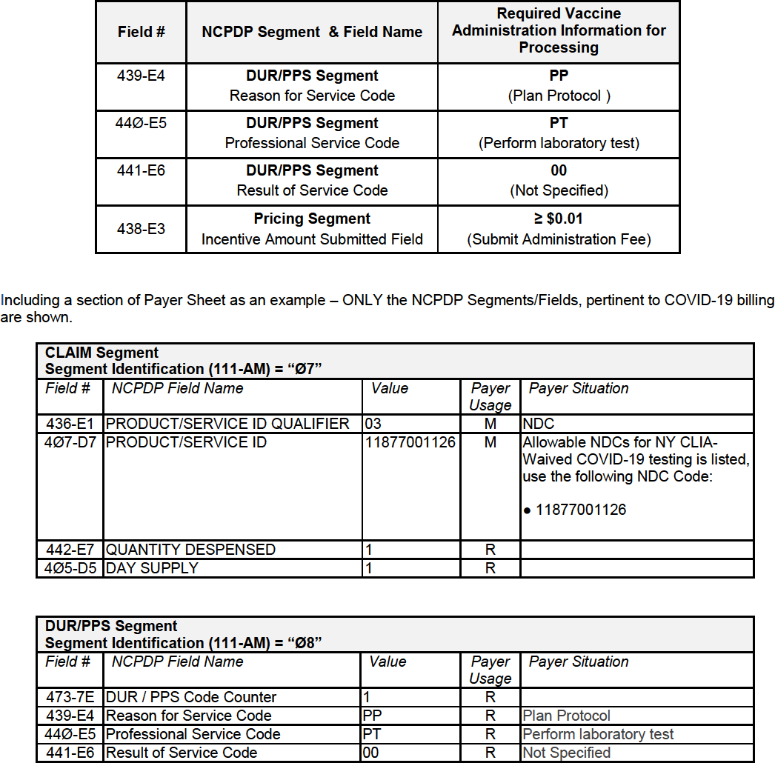

Example NDC/UPC codes only and not limited to the following:
